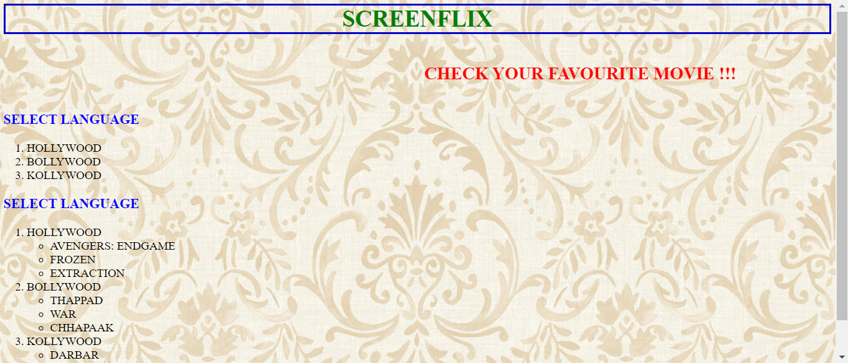

EXTERNAL STYLESHEET

CSS STYLING IS DONE IN A SEPARATE CSS FILE

SCREENFLIX – H1 TAG WITH BOLD IS USED AND BORDER STYLE IS GROOVE BORDER COOR IS GREEN

CHECK YOUR FAV MOVIE – MARQUEE AND H2 TAG WITH CLASS ATTRIBUTE IS USED FOR CSS COLOR

SELECT LANGUAGE – H3 TAG WITH CLASS ATTRIBUTE IS USED FOR CSS COLOR

HOVERING ON THE LIST ITEM USED WITH CSS COLORS